1. Create a Hive Table including Complex Data Types:

1.Creating hive table using zomato with complex data types as follows:

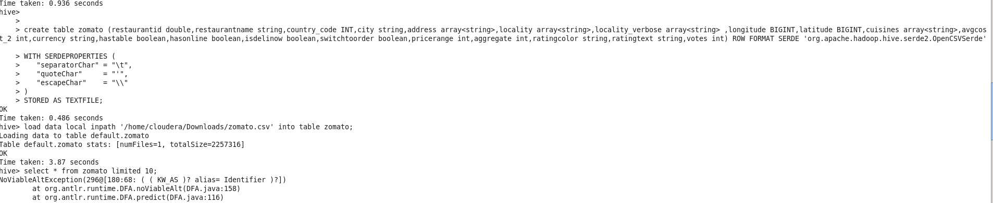

Here table is created using comples datatypes with serde properties to handle quotes and comma delimiter in zomato dataset.

2. Creating second table and upload it in the hive as follows:

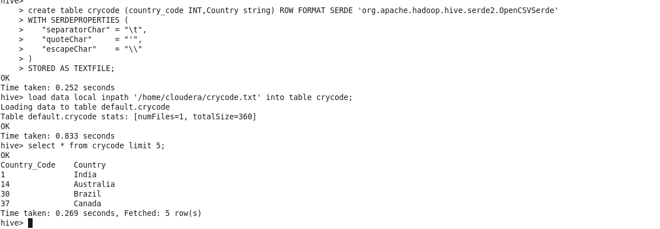

B.Use built-in functions in your queries:

1.Max() and row_number() are the 2 built in functions we have used in hive:

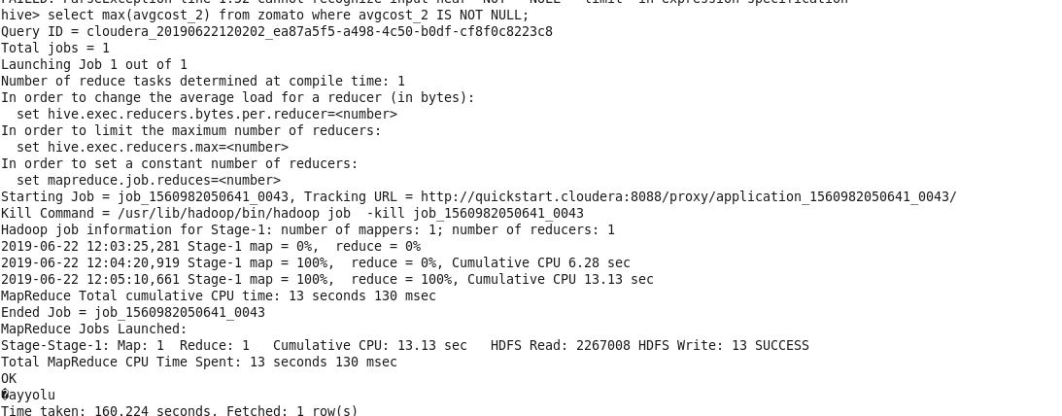

2.The row_number() function is useful while handling sql query in database:

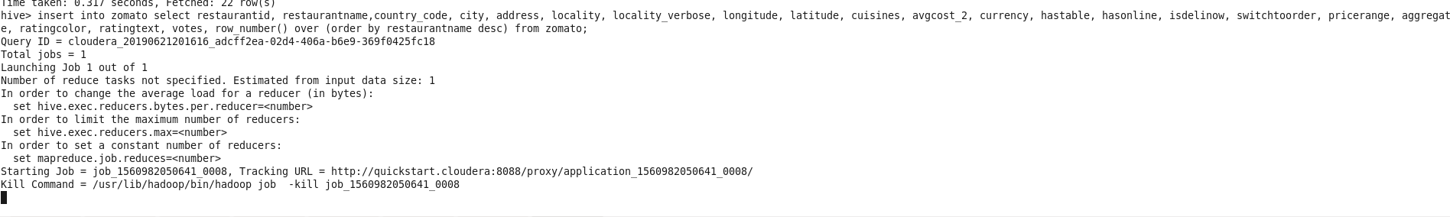

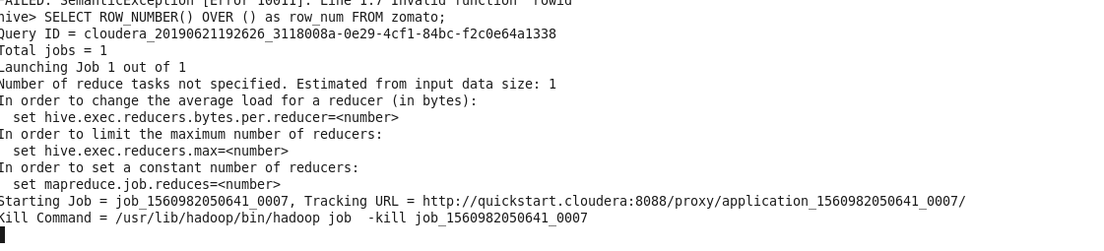

The rowid is column is inserted at the end of the column as follows:

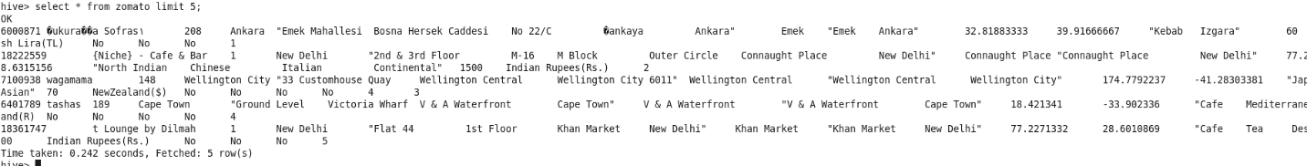

C.Perform 10 intuitive questions in Dataset (e.g.: pattern recognition, topic discussion, most important terms, etc.). Use your innovation to think out of box.

3. Pattern recognition is done as follows:

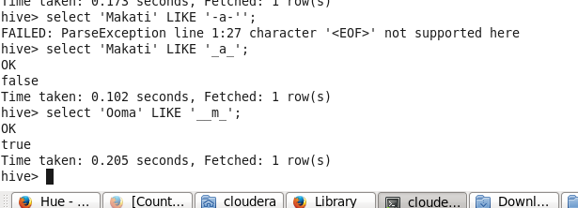

4. Nullvalue deletion in the hive table:

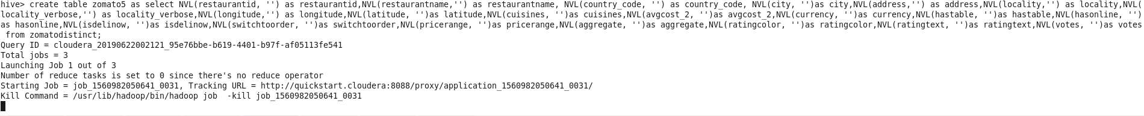

5.By selecting the notnull values and creating the rownumber we will delete most of the null values inside the table while doing the table cleaning process:

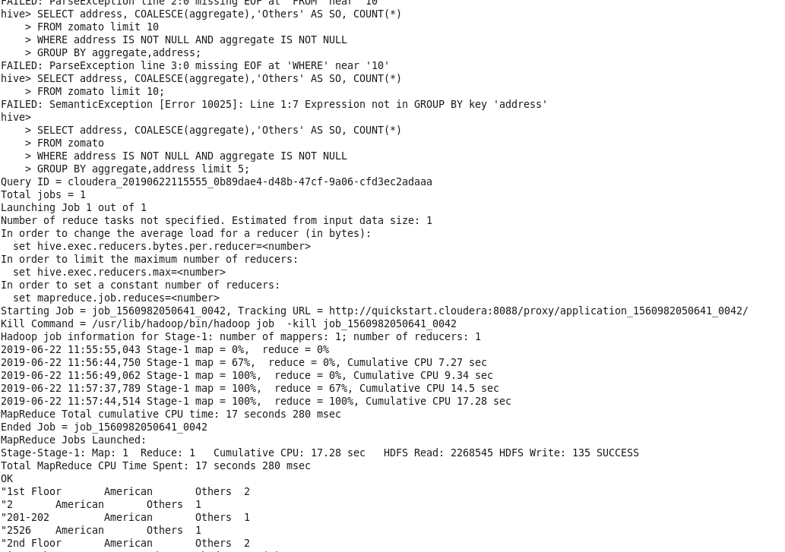

6.By creating the distinct table so that the duplicate values are deleted in the table which is also a cleaning process:

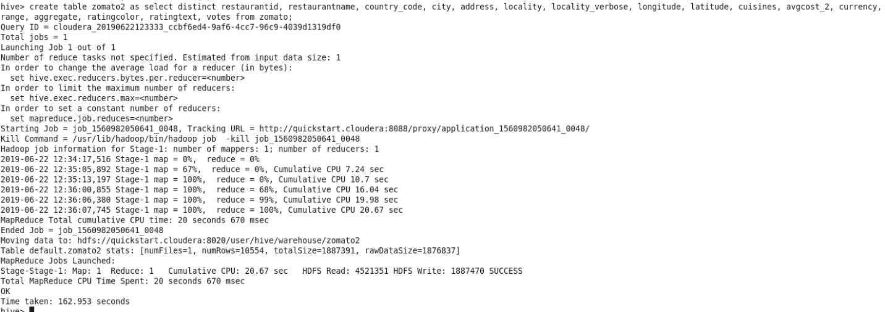

7.Creating views in a database is always known for hiding certain personal information so that everyone cannot see the hidden view in a database.

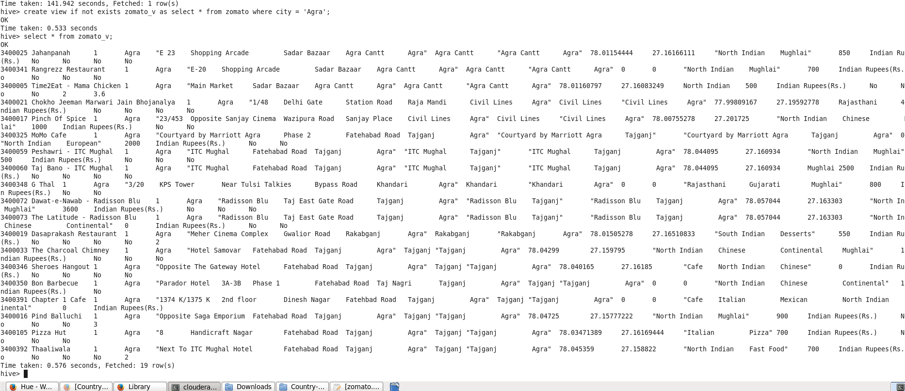

8.AS in the columns in the dataset are similar hence we perform joints as follows:

1.Equijoin:

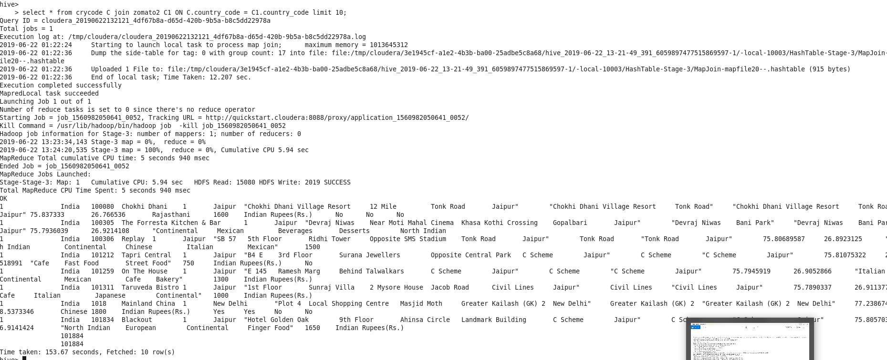

2.Right outer join:

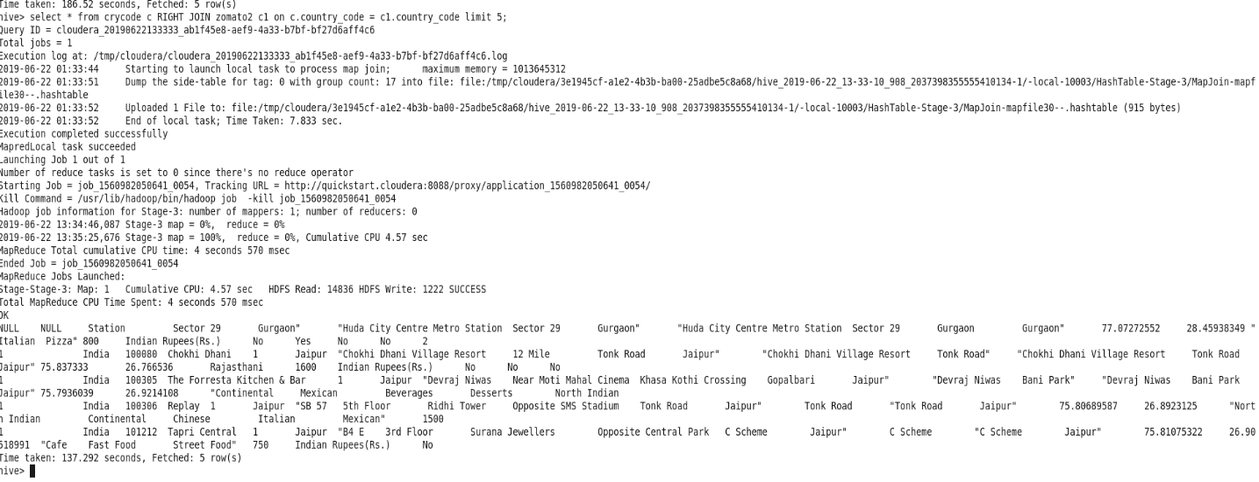

Thus using the dataset of 9558 rows and 22 column including rowid we have cleaned the dataset and got the output for all important queries that is necessary for the corporate culture.